Computer assisted telephone interviewing (CATI): Resource Pack
This resource pack provides practical guidance on how to use CATI within SurveyCTO. The pack was developed in collaboration with SurveyCTO and is based on their own Basic CATI Starter Kit.

The aim of the resource pack is to provide a step-by-step walk-through for using CATI, applying an approach that is already contextualized for international development and humanitarian work. This resource pack assumes some prior knowledge of using SurveyCTO.

It should be noted that SurveyCTO provides two options for using CATI: case management or non-case management (see Additional information for further details). Based on experiences when piloting the software, this resource pack follows Oxfam’s preferred approach, non-case management. More advanced features are also available when using SurveyCTO’s Advanced CATI workflow, but these are not included within this resource pack.

What do i need to get started?
The following resources are required in order to use the system:

Required Resources: | Desirable Resources:
- SurveyCTO subscription  - Knowledge of SurveyCTO (form building, user management and data collection)  - Phone numbers of the people you want to interview  - Your data collection tool (survey) in Excel format (XLS)  - Smart phone handsets  - Phone coverage/airtime budget | - Headsets/headphones

A note on XLS forms: This resource pack assumes familiarity with XLS form building, which means the ability to build your surveys using an Excel form, rather than SurveyCTO’s online form builder.

How do I set up CATI?
Broadly speaking, there are five steps (with a sixth optional step) to setting up CATI on SurveyCTO. The resource pack will talk you through each of these.

Step 1: Integrating CATI into your data collection tool (survey)
Step 2: Preparing the call list
Step 3: Uploading to SurveyCTO
Step 4: Setting up your data-collection device (mobile phone)
Step 5: Training your data-collection team
Step 6: Setting up the dashboard (optional)

Additional information

At the end of the annex you can find additional information on the following topics:
- Audio audits
- Case management vs. non-case-management
- Encryption
- Further support

Step 1: Integrating CATI into your data collection tool

1.1 | Download and open the CATI Survey Template (Excel). Click to enable editing.
1.2 | Go to the Settings tab. Enter a form title and ID into the blank cells highlighted in yellow.  Important Notes:  - Your form ID cannot contain spaces, instead you should replace these with underscores e.g. Phone_survey_PDM
1.3 | Open your data collection tool (e.g. Household Survey, Post Distribution Monitoring tool) in XLS format.
1.4 | You must now copy and paste your survey into the CATI Survey Template (Tab 1: survey). These must be copied and pasted into the blank space between Row 46 and Row 68.  Important Notes:  - In order to do this, you can add or remove as many rows as you need.  - You should copy and paste all the data, including data under columns such as Relevance, Constraints, etc. If you are copying and pasting an entire row, ensure that the Excel column headings in both sheets are in the same order.  - Meta data, consent and closing/thanking notes are already included in the template, you therefore do not need to copy these. Do not attempt remove those already contained within the form as they are linked to wider form functionalities.
1.5 | You must now repeat this process for your choice lists (answer options).  Copy and paste your choice lists from your data collection tool into the CATI Survey Template (Tab 2: choices)  Important Notes:  - Do not delete choice lists already within the template. However, some choices (e.g. yesno) are already included in the form, so you may need to delete any duplicates if these are also included in your own choice lists.
1.6 | Edit the consent section as per your needs and requirement. To do this, you should replace the data in cell C41 with the consent question that has been contextualized for your data collection.  Important Notes:  - For more details on capturing informed consent, visit Oxfam’s responsible Data Management Training Pack and the fifth paper of the Going Digital series  - The answer options to consent question are already contained in the form and should not edited. The answer options are as follows:  - Consents to complete the survey now  - Consents to complete the survey, but not now  - Does not consent to complete the survey
1.7 | You can set a maximum number of call attempts for CATI. For example, if a total X number of calls are made to a respondent with no answer, no further attempts can be made, and the interviewee will be automatically removed from the call list.  As default, this is set to 3 calls. To increase/decrease this, you need to edit the information in the calculation column of Row 30 ‘stop_at’ (Cell Q30). For example, if you wish to have a maximum of 5 calls, this should be changed from int(3) to int(5).
1.8 | Save a copy of the form and proceed to Step 2.

Step 2: Preparing the call list

Before you begin… This is where you will be entering the details of your interviewees. You will therefore need to have contact details (e.g. phone numbers) of your interviewees before completing this step.

2.1 | Download and open the Respondents Template Excel file. Click to enable editing.  Important Notes:  - Alongside the template, there is a filled example of a prepared call list available in the resource folder Respondents Example (Filled in)
2.2 | Fill in the Excel file with the details of your interviewees. The table below  provides guidance on the information that should be entered into each column.
2.3 | Once you have added all the details of your interviewees, you need to save the file.  Important Notes:  - If the list is very long, it is recommended you save the file as a CSV as it will upload faster.

respondents_details | id_key | users | resp_pn | full_name | address | num_calls | callback_time | last_call_status | needs_review | now_complete
This column contains a formula and will auto-populate when other cells are filled in.  Once you have added your data, drag this column down to apply the formula to all of your rows. | Each interviewee should be given a unique numerical ID key. It is recommended that for ease, you start this number at 1 and increase by 1 each time | This column is used to assign calls to each of your interviewers.  To do this, you must fill this column with the username of the interviewer to whom you want to assign the call. The username will have been assigned to them when you added them as a user to SurveyCTO. | Enter the phone number of the interviewee. Note: The phone number will appear identically in the dialler. Therefore, if you require country dial codes to make the call, ensure these are included within the Excel file. | Enter the name of the interviewee. | This can contain information about the location of the interviewee. For privacy reasons, it is recommended that you do not enter a specific address, but rather the Governorate, District or Sub-District where the interview resides. | Set to ‘0’ | No action required: leave this cell blank | No action required: leave this cell blank | No action required: leave this cell blank | This cell must always contain ‘No’

Step 3: Uploading to SurveyCTO

Before you begin… In order to be able to deploy your form design and the respondents list in a server dataset, you'll need to be logged in with a user with appropriate permissions.

3.1 | Download the following zip files from the Resource Pack:  - Phone Call Plug In: https://github.com/surveycto/phone-call/raw/master/phone-call.fieldplugin.zip  - Table Plug In: https://github.com/surveycto/table-list/raw/master/table-list.fieldplugin.zip
3.2 | Log into SurveyCTO and open the Design tab.
3.3 | Create a group. This is where you will upload the XLS and Excel/CSV file you developed in Step 1 and Step 2.
Within the group, click the button Add a form, dataset or sub-group

Click Upload Form Definition and select the Excel file you created in Step 1 (CATI Survey Template).

When uploading, attach the plug ins (Phone Call and Table) as annexes. These should be uploaded as zip files. Do not extract the content.

Click Upload.

3.4 | In the same group as your XLS file, you need to create a dataset. To do this, click the ‘+’ button and then Add server dataset. When you click this, the dataset will default to New dataset for data. Do not amend this.  The dataset title and ID should be set to ‘respondents’. If you already have dataset called ‘respondents’ located within your server, please follow the instructions in the box on the next page.  You then need to select the Excel or CSV file you prepared in Step 2 and click Create dataset. Once the dataset is created, you will see the Data Preview box (preview on next page) on the screen. Select Keep it.  ALREADY HAVE A DATASET CALLED ‘RESPONDENTS’?  If you already have a dataset called respondents within your server, for example from a previous set of interviews, you will not be able to create a second. Instead, you can call the dataset another name, for example: respondents2. If you do this, you will also need to make some small edits to the data collection tool you developed in Step 1.  To do this, open your data collection tool. In column N, you will have your calculation functions. Currently, these are set to instruct SurveyCTO to pull data from the dataset called respondents.  To change these, highlight Column N and then select Find and Select > Replace  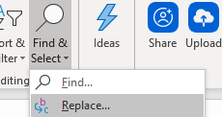  You must then replace references to respondents to the new name of your dataset e.g. respondents2  You must also update ‘respondents’ which is included in Cell F17 e.g: search('respondents2', 'matches', 'now_complete', 'No','users',${username}) custom-table-list(delimiter='|',headers='id,Name,Address,Attempts, Call back time, Last Status')  Once you’ve made changes to your XLS form, do not forget to upload the latest version to the server.  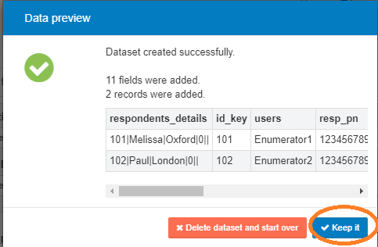
3.5 | Your created dataset will now appear within the group.  Click Publish into which appears on the right of the dataset name, followed by Add a form.  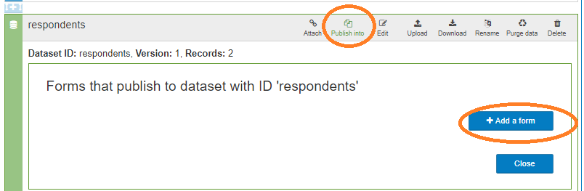  Select your data collection tool that you uploaded in Step 3.3.
3.6 | Click the Add button under the form name, and then fill out the field mapping table so that it matches the table on the next page.  In order to complete the mapping, add a line and then select the correct field in the text box on the left hand side. The text box on the right will automatically populate with the same content. In some cases, you will therefore need to delete the contents of the text box and change it using the drop-down menu.
3.7 | 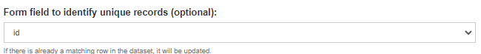  Select Id in the Form field to identify unique records. Leave everything else blank and click save.
3.8 | Select the Attach option, which appears on the dataset (next to publish into).  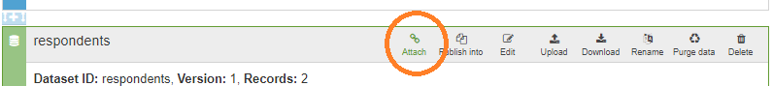
3.9 | Find and select the survey you created in Step 3.3 and then click Close.  Important Notes:  - Your table will appear empty unless calls are assigned to your username under the ‘users’ column of your respondents file.

Step 4: Setting up your data collection device

Choosing the right settings

In order for the case list to update after each call/call attempt is completed, you will need to activate certain settings within your SurveyCTO Collect App. To access settings, open the App and click the three dots in the right hand of the corner, followed by General Settings.

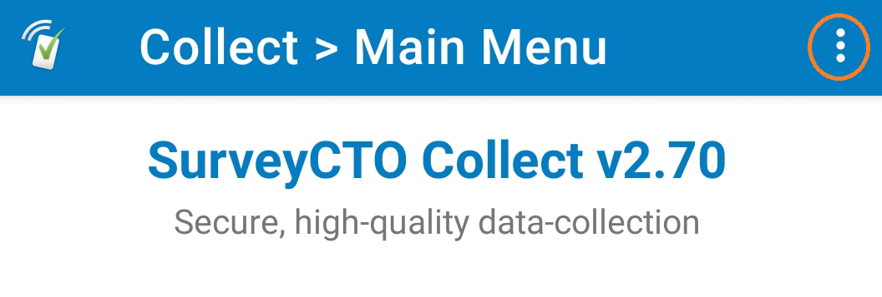

Once you have opened General Settings, you should select the following options. These will ensure that the call list is able to update automatically with the outcomes of each call attempt:

- Auto send with Wi-fi
- Auto download with Wi-Fi
- Auto download on demand

To ensure the ‘call list’ data is stored safely on the device, the following Admin Settings should be activated. To access this, click the same three dots shown in the image above, followed by Admin Settings.

- Admin Password: Set a password to lock admin settings on the device before distributing to the data collection team
- App Passcode: This will ensure that a password is needed in order to open the SurveyCTO collect app.
Finally, it is recommended that you open your mobile phone in landscape (by turning on the phone’s auto-rotate function); you might not be able to see all of the call list table in portrait mode on smaller screens.

The forms and device should now be working! You should now test them!

Step 5: Training your data-collection team

As with any data collection, particularly when using new approaches or softwares, detailed training should be carried out with the data-collection team to ensure safety and effectiveness.

The annexed training materials and example protocol can be used as guidance for this.

Step 6: Setting up the dashboard (optional)

Before you begin… The steps below are guidance for setting up a basic dashboard using MS Excel. However, you can adapt and edit this depending on the data you wish to show. You do not need to have a dashboard in order to use CATI, however, it will make the monitoring process easier.

6.1 | In order to set up the dashboard, you should first make a second dataset that holds all the data which you would like to have visualized within the dashboard.  To do this, log into SurveyCTO and click on the Design tab.  Locate the group that contains your data collection tool and respondent dataset and click to Add Server Dataset. The dataset will default to New dataset for data, do not change this.  You can call the dataset any name you like. We recommend dashboard data (ID: dashboard_data_projectname).  You can then click Create Dataset. Do not select any files to upload.
6.2 | On the dataset, then click Publish into followed by Add a form. You should select your data collection tool (surveyl).  You should then add the following fields to the field mapping. You can always add more fields, depending on the data you want to include in your dashboard. However, you should never include personal or sensitive data in the field mapping – these are not appropriate fields to be included in dashboards.  Once you have completed the mapping, leave the following fields blank: Form field to identify unique records and Include form submissions whenever the field is 1.  Tick the box that says Publish existing data
6.3 | The next step is to link the data from this dataset into your dashboard.  Open a new, blank Excel file.  In one worksheet, you need to click Data in the tool bar followed by Get data from Web  To make the connection to your dataset you will use a URL constructed as the example below:  https://SERVERNAME.surveycto.com/api/v2/datasets/data/csv/YOURDATASETNAME  For example:  https://oxfamdemo.surveycto.com/api/v2/datasets/data/csv/dashboard_data
6.4 | If this is the first time linking the data to Excel, you will need to provide your SurveyCTO credentials.  Click on Basic and then enter your SurveyCTO Username and Password  You will then be presented with a preview of your data. Click Load.
6.5 | While you can manually refresh your data by simply pressing the Refresh button, you can also set the data to automatically update.  Click Refresh All followed by Connection Properties  You can then select whether you want the data to refresh automatically at time intervals, or as a minimum, each time it the file is opened.
6.6 | Once your data are imported and set to refresh, you create a second tab in the Excel file. You can then create your dashboard using tables and graphs.
7. Additional information
7.1 Audio audits
The audio audit functionality is not included in the resource pack templates. Therefore, you will not be able to listen back to any of your interviews when exporting the data. You can find information on how to add the audio audit in SurveyCTO’s documentation.
7.2 Case management vs non-case-management
SurveyCTO provides two approaches to using their Basic CATI Starter Kit: one using the case management functionality and the other not. The templates provided in this resource pack are built from the non-case-management approach
7.3 Encryption
If you are planning on encrypting your data, you will need to make sure that some fields are ‘publishable’ so that the respondent data can still be pushed through and appear on the call list. In order to do this, you should ensure that ‘yes’ is written in the publishable column for the following fields in your data collection tool:

name | publishable
username | yes
caseid | yes
phone_call_duration | yes
users | yes
pub_to_users | yes
callback_time | yes
new_sortby | yes
call_num | yes
needs_review | yes
now_complete | yes
phone_response_short | yes
Important Notes:
- For privacy and security reasons, do not make fields containing personal or potentially sensitive data publishable.

7.4 Further support
If you have any questions on using CATI within SurveyCTO, you can visit their SurveyCTO Support Centre.,

Details incl. costings can be found here: https://www.surveycto.com/
https://policy-practice.oxfam.org.uk/publications/responsible-data-management-training-pack-620235
https://policy-practice.oxfam.org/resources/going-digital-privacy-and-data-security-under-gdpr-for-quantitative-impact-eval-620884/
https://docs.surveycto.com/04-monitoring-and-management/01-the-basics/00b.managing-user-roles.html
If you are not using Wi-Fi, but instead mobile data/network, select Auto send with Network instead.
If you are not using Wi-Fi, but instead mobile data/network, select Auto download with Network instead.
You can find more information about the two approaches, and the differences between them here: https://docs.surveycto.com/03-collecting-data/03-data-collection-workflow/02.case-management.html
https://docs.surveycto.com/02-designing-forms/01-core-concepts/03ze.field-types-audio-audit.html
https://support.surveycto.com/hc/en-us

